Report



Indian Institute of Information Technology Allahabad

Department of Information Technology



REPORT



**RESTAURANT RECOMMENDATION EXPERT SYSTEM**



Supervisor: **Prof. Anupam Agrawal**

IIIT ALLAHABAD

Indian Institute of Information Technology, Allahabad

(A UNIVERSITY ESTABLISHED UNDER SEC.3 OF UGC ACT, 1956 VIDE NOTIFICATION NO. F.9-4/99-U.3 DATED 04.08.2000 OF THE GOVT. OF INDIA) A CENTRE OF EXCELLENCE IN INFORMATION TECHNOLOGY ESTABLISHED BY GOVT. OF INDIA

November 17, 2019

|  |  |  |  |
| --- | --- | --- | --- |
|  | Report | | |
|  |  |  |  |
| **Contents** |  |  |  |
| **Candidate’s Declaration** |  | **5** | |
| **Acknowledgement** |  | **6** | |
| **Abstract/Objective** |  | **7** | |
| **Introduction** |  | **8** | |
| **Related Works/Literature Survey** |  | **9** | |
| **List Of similar Expert System Model** |  | **10** | |
| **Novelty of work and contribution** |  | **11** | |
| **Background** |  | **12** | |
| Real Time Expert System . . .  Knowledge Base and  Inference Engine …………. | ................... | 13 |  |
| About Dataset related . . . . . . . . | ................... | 13 |  |
| **Tools and Techniques** |  | **14** | |
| Environmental Setup . . . . . . . . . | ................... | 14 |  |
| Use Case Diagram . . . . . . . . | ................... | 14 |  |
| Implemented Modules . . . . . . . . . .. | ................... | 15 |  |
| **Proposed Model** |  | **16** | |
| Quick View . . . . . . . | ................... | 16 |  |
| All the Features . . . . . . . . . . . . . | ................... | 16 |  |
| Field Description . . . . . . . . . . . . . | ................... | 16 |  |
| Working and Limitation . . . . . | ................... | 17 |  |
| **Results** **and Comparisons** |  | **19** | |
| Result of Proposed Model . . . . . . | ................... | 19 |  |
| Comparison with the results of existing module . . . . . . . . . . . . | ................... | 19 |  |

|  |  |  |
| --- | --- | --- |
|  | Report | |
|  |  |  |
| **Conclusion** | **20** |  |
| **References** | **20** | |

Page 4 of 20

Report



**Declaration**

We hereby declare that the work presented in this project report of B.Tech (IT) 5th Semester entitled **“Restaurant Recommendation Expert System”**, submitted by us at **Indian Institute of Information Technology, Allahabad**, is an authenticated record of our original work carried out from us under the guidance of **Prof. Anupam Agrawal**. Due acknowledgements have been made in the text to all other material used. The project was done in full com-pliance with the requirements and constraints of the prescribed curriculum.

|  |  |
| --- | --- |
| Place: Allahabad | Aditya Raj(IIT2017005) |
| Date: 17 October,2019 | Sameer Kathal (IIT2017010) |
| . | Aman Saxena (IIT2017021) |
| . | Nishant Kumar(IIT2017023) |
| . | Sneh Sameer (IIT2017028) |
| . | Aditi Aggarwal(IIT2017030) |
| . | Divyanshu Abhishek(IIT2017036) |
| . | Manish Kumar Jagnani(IIT2017503) |

Page 5 of 20

Report



**ACKNOWLEDGEMENT**

We have tried our best to present this project in a complete manner with-out failing the deadlines, in this project. However, it would not have been possible without the kind support and help of many individuals.We are thankful to **Mr.G.C Jana**,for availing us with resources and continuous support that helped us to carry out this project.We would like to extend our sincere thanks to all of them. We are highly indebted to **Prof. Anupam Agrawal** for his guidance and constant supervision as well as for providing necessary information regarding the project whenever we were stuck. We are largely indebted to them for their support in the project.

Page 6 of 20

Report



**Abstract**

Technology has created a platform for growth of businesses online. Due to rapid increase in information on internet recommendation systems are widely popular all around. It is applicable in many fields such as E-Commerce site, music, movie, book location and Restaurant recommendation.

Restaurant recommendation system is a very popular service whose accuracy and sophistication keeps increasing every day. With this era of technology this has become accessible by every customer.People can obtain any information they want whenever and wherever. Recent years, recommender system has become an effective way to provide people with personalized and useful information.

Selecting the restaurant according the rating and cost filters out the restaurant and recommend according to that. This is the main factor considered in our system.

Page 7 of 20

Report



**Introduction**

Food is not just a necessity of life, it also represents our culture,tradition and values. While visiting a place one of the most important factors we consider is the varieties of food and places available there. But,one of the major problems is that people are unaware of the famous restaurants and places available at that particular place. With the increase in the number of restaurants people often gets confused for the best-suited restaurant according to their preferences and faces hard time to find out the best place and food to eat.

Restaurant Recommendation Expert System is a rule-based expert system which primarily aims to suggest users the best food to eat in the given city based on their preferences. The application targets everyone who wishes to go to a restaurant to eat and have an outing.

The application takes the food preference into consideration to recommend food to the users. The system asks user some set of predefined set of questions and on the basis of the answer given by user. The recorded responses of the user updates the knowledge base. From this knowledge base CLIPS uses forward-chaining to infer the solution. Every time a rule is fired, it searches through the present knowledge base. If the conditional fact is present in the database it will assert a new fact in the database.

Page 8 of 20

Report



**Related Works/Literature Survey**

In the past not much work is done in this field.We got hold of three recommender systems which are also doing similar work:

1**. Gadget-Recommender system** : It recommends User a gadget based on his preferences such as budget , Brand , Type of gadget which he wants. In this they have stored facts in the database and upon answering queries by the user the rules defined in clips prune the decision tree accordingly and suggest the leaf node. This was done on CLIPS interface only and no GUI was provided.

2.**Flower-Identification System** : It Identifies flower’s name by taking

properties such as type_of_soil, Plant_Height , Root_Type, Season etc. into

consideration . The facts are previously stored in the database and upon filling

the characteristics of the unknown flower , clips uses forward chaining to match the facts.

Page 9 of 20

Report



**List Of Similar Expert System Model**

|  |  |  |
| --- | --- | --- |
| **Project Name** | **Brief Description** | **Repository Link** |
| Gadget Recommendation System | Recommends gadget based on type, budget and brand preference of the user. | <https://github.com/B-arryAllen/Gadget-Recommendation-Expert-System> |
| Flower Identification System | Identifies flower’s name by taking properties such as type_of_soil, Plant_Height , Root_Type, Season etc. into consideration. | <https://github.com/Ghamry0x1/FlowersCLIPS> |
| Animal Identification System | Identifies animal’s name by taking some of its characteristics into consideration. | <https://github.com/smarr/CLIPS/blob/master/examples/animal.clp> |

Page 10 of 20

Report



**Novelty Of work and Contribution**

The aim of our project is to provide user list of some restaurants based on his/her preferences of city,veg/Non-veg, cuisine, budget and rating of the restaurant.

There was no restaurant recommendation project based on the frameworks of CLIPS as backend and Java as User Interface.Also the projects which were developed under this genre did not actually use the concept of Expert Systems but in our project, we have implemented proper Expert System Concept.

The approach we have used provides easy updation, insertion and deletion of any restaurant in the database by loading a CSV file.

Our project lists all possible restaurants based on the user’s preferences by taking advantage of Forward Chaining capability of CLIPS.

Page 11 of 20

Report



**Background / Materials and Methods**

**Real Time Expert Systems**

The restaurant recommendation expert system uses Rule-based recommendation technique for producing restaurant recommendations. Basically,recommendation engine it helps the users to find their preferences based on questions asked

by the system.Recommendation systems solve these kind of problems by exploring the user preferences.Based on the user inputs, the inference engine fires the rules. The restaurant shown in the results who are the best according to the preferences provided.

The CLIPS shell provides basic elements of the expert system.

* Working memory : Has the fact-list, and instance-list.
* Knowledge-base: Contains all the rules, the rule-base.
* 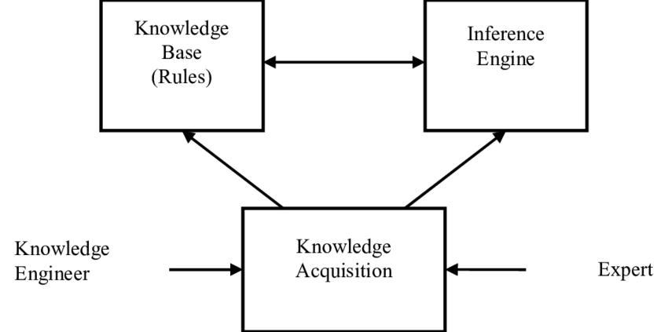Inference engine: Controls overall execution of rule .

Page 12 of 20

Report



**Knowledge Base**

The knowledge obtained by the online surveys and statistics are used to create rules for our knowledge base .Online data have information about the restaurants in particular city. And we made our own facts using the information from the online sources and loading them to CSV which is further loaded into CLP file upon execution of software.,

**Inference Engine**

Facts present in knowledge base are filtered according to rules in knowledge base we give output to the user.If all the user input attributes matches with a fact in the knowledge base then system will give an output and if none matches then will remove the least attribute one by one and then again search the knowledge base and provides the output found.The inference engine based on the knowledge base and it’s several classifications can be illustrated , say as an example if a person

have five requirements in the restaurant he wanted to visit but only three of them are present in the location A and remaining two requirements in other location B then our inference engine will execute the priority rule in the knowledge base and gives the output as the A .

**About dataset preparation**

We have manually added the database for 2 cities i.e Allahabad and Lucknow. 2 restaurants in total are added in the database each having characteristic features as mentioned in the Restaurant Class. Same restaurant can serve both Veg and Non-veg , multiple Cuisines at the same time. However Rating and price range of each restaurant is fixed and cannot have multiple values simultaneously.

Page 13 of 20

Report



**Tools and Techniques**

**Environmental Setup**

The project can work on any general computer with Windows, Mac or Linux operating systems. The only requirement is that the CLIPS Inference Engine should be installed in the system and java environment setup should be there in the system. JavaFX is used for GUI part , So the JavaFX module should be attached with the respective IDE. Path of the Dynamic-Link Library file of CLIPS JNI module(discussed in the following sections), should be provided in the System variable path. The jar file of CLIPS JNI should be provided in the library(lib) folder of the project.

**Use Case Diagram**

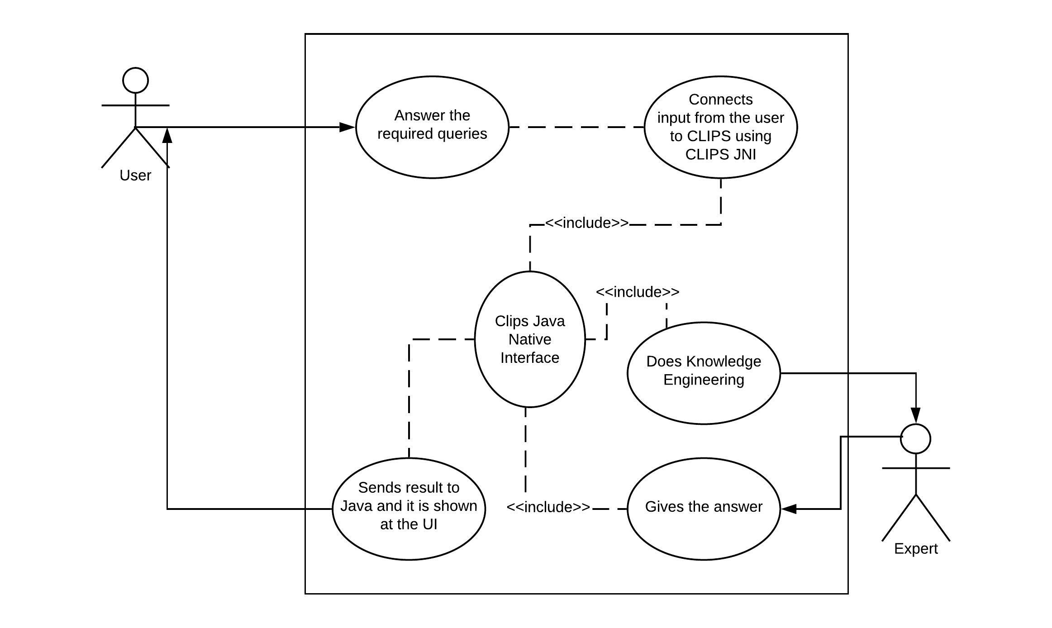 Page 14 of 20

Report



**Implemented Modules**

**CLIPS JNI**

It stands for CLIPS Java Native Interface. CLIPS JNI demonstrates basic techniques for integrating CLIPS with a Java. CLIPS JNI also includes an Integrated Development Environment (IDE) for writing and debugging CLIPS programs.

**JavaFX**

JavaFX is the GUI library in Java. It provides many functions which is used to make a User-Interactive Environment very easily in a java program.

Page 15 of 20

Report



**Proposed Model / Framework**

**Quick View**

User will interact through the GUI provided. Answers to different questions like location, cuisine, budget etc are to be provided by the user and after getting the answers to the required questions, the expert system will fire the rules and after inferencing from the knowledge base it will show all the restaurants that satisfies the given constraints.

**Features of the System**

Following features are being provided in the system :

* A graphical user interface ( GUI ) for the users to interact with the system for a better user experience.
* Easy Updation of restaurants by changing a CSV file.
* Recommendation based on multiple factors, the specification of which is to be provided by the user.
* Also shows enhanced recommendations that are of the best value for the same budget along with the recommendation exactly according to the given user preferences ( e.g if user asked for restaurant with certain rating then the system will also show restaurants with better rating for the same budget and other factors ).

**Field Description**

Following fields are considered :

* **Location** : The city in which the restaurant is located ( e.g Allahabad, Lucknow etc ).
* **Food Type** : The type of food offered at the restaurant ( e.g Vegetarian, Non-Vegetarian ).
* **Cuisine** : The food of different regions being offered by the restaurants ( e.g Indian, Italian, Chinese etc ).
* **Budget** : The per person average price of the food at a particular restaurant ( e.g under 150 Rupees, 150 to 300, over 300 rupees ).

Page 16 of 20

* **Restaurant Rating** : The rating of the restaurant according to 3 star Michelin Rating.

**Working**

We are taking input from the user through the graphical user interface ( GUI ) provided. These input is then sent to the CLIPS using CLIPS JNI where the Inference Engine fires and matches procedures and gives the result which is then sent to the Java Graphical User Interface using CLIPS JNI. The list of resultant restaurants is shown using list to the User Interface.

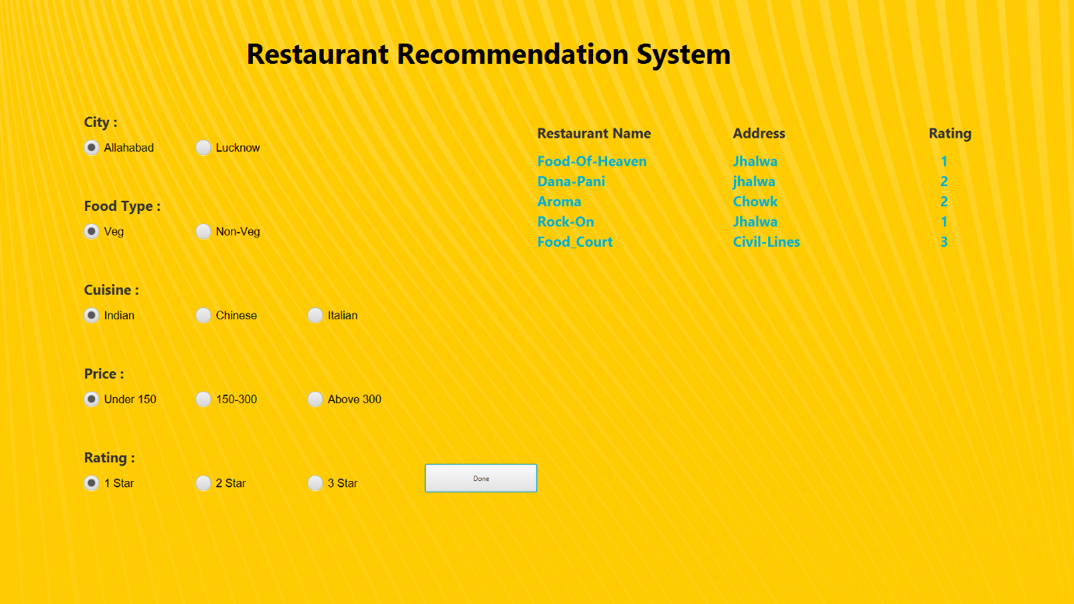

GUI figure

**System Limitations**

* Limited and finite data set.
* Limited cities are covered.
* Only popular restaurants are covered.

Page 17 of 20

**Expert System Life Cycle**

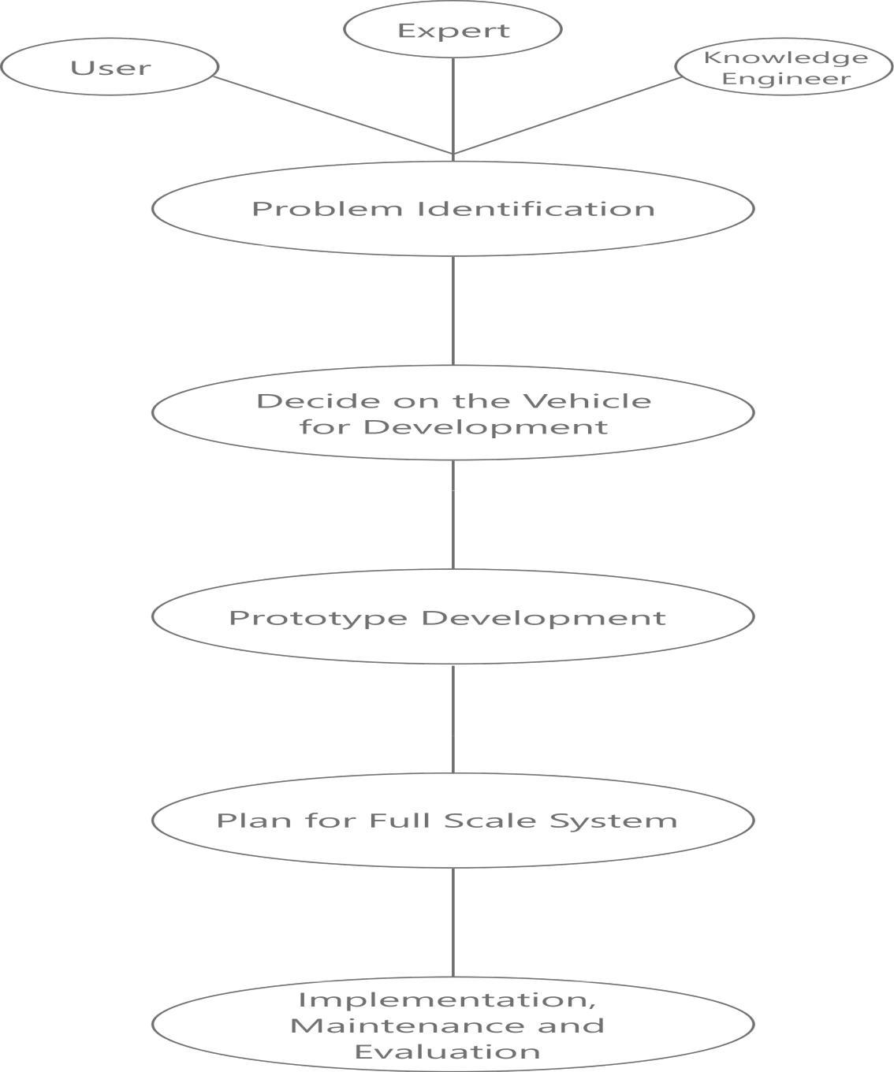

**Figure 1:** Flow Diagram

Page 18 of 20

Report



**Result and Comparisons**

**Result of Proposed Model**

We are taking input from the user and then sending it to the CLIPS using CLIPS JNI and then Knowledge Base comes into the rule.

Our Inference Engine does fire and match procedure and gives the result to and it is sent to the Java User Interface using CLIPS JNI. The list of resultant restaurants is shown using list to the User Interface.

**Comparison with the Results of Existing Module**

There are projects on Gadget Recommendation System,Flower Detection, Animal Detection and so many but not specifically on Restaurant Recommendation System using CLIPS. CLIPS Java Native Interface is also used which is quite complex when it comes to attaching it with the Java program for User Interface but at the same time, it is quite useful as well.

There are recommendation projects on CLIPS which shows only one result but here in this project , user can get multiple recommendations for the restaurant depending on the inputs provided by the user at the interface.

Page 19 of 20

**Conclusion**

* While making this project, all criteria for any particular restaurant is taken into consideration and it is observed that how much any criteria is important for any restaurant to classify it into a particular class.

**Future Scope**

* We can use more criteria to get more filtered results in the list of resultant restaurants.
* We can provide review system for the user for any particular restaurant and it can be used to get more enhanced result in future time.

* We can provide more restaurants in our database with respective details about that restaurant. It can be more useful for the end-user because now he/she will have more options to choose from.

**References**

* Clips Programming Documentation : [Clips : A Tool for Building Expert System](http://www.clipsrules.net/)
* Video Tutorial for using CLIPS With Java using CLIPS JNI : [Video Tutorial for using CLIPS JNI in Java for CLIPS Expert System](https://www.youtube.com/watch?v=I_lgFs_cVPw)
* Documentation on how to use CLIPS JNI with Java in an Expert System Project using CLIPS : [CLIPS JNI Documentation](https://www.csie.ntu.edu.tw/~sylee/courses/clips/clipsjni.htm)

Page 20 of 20